SQL: Finance Analytics

1.first grab customer codes for Crom

Output

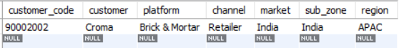

USER DEFINED FUNCTIONS

2. create a function 'get_fiscal_year' to get fiscal year(begins in September) by passing the date

4.Croma India product wise sales report for fiscal year 2021

5.Gross Monthly total sales report for Croma

Output

6.Get Yearly Gross sales report for Croma India

Output

STORED PROCEDURE

8.Create a stored procedure to get monthly gross sales for customers having 2 customer codes 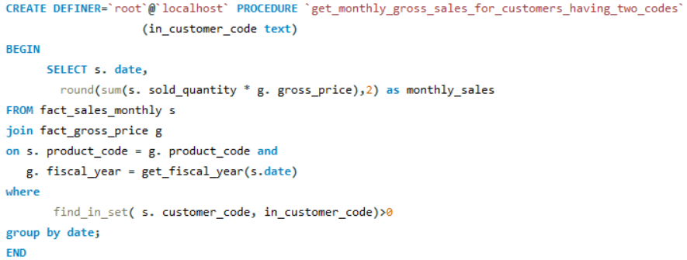

9.Create a stored procedure to get market badge

#If total sold quantity >5million that market is considered Gold else it is Silver A screen shot of a computer code

AI-generated content may be incorrect.

Top Market, Customers and Products Analysis

PERFORMANCE IMPROVEMENT

10.Added the fiscal year in the fact_sales_monthly table itself to get pre invoice discount pct

DATABASE VIEWA

Now generate net_invoice_sales using the above created view "sales_pre_invoice_discount"

Now generate net_sales using the above created view "sales_postinv_discount"

14. Get top 5 market by net sales in fiscal year 2021

Output

16. Get top 5 Customers by net sales in fiscal year 2021

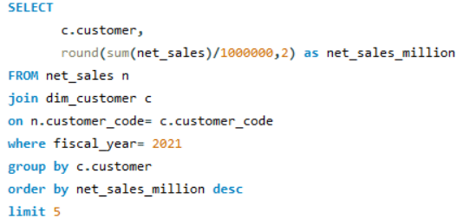

Output

18. Get top 5 Products by net sales in fiscal year 2021

Output

WINDOW FUNCTION OVER CLAUSE

20. find out customer wise net sales percentage contribution

Output

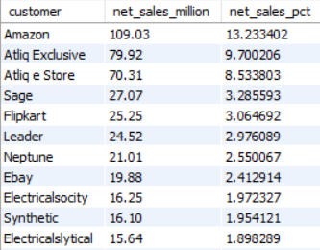

Top 10 Customers by Net Sales% Share

Output

Top 10 Customers for APAC-Region

WINDOW FUNCTION DENSE RANK

22. Find out top 3 products from each division by total quantity sold in a given year

Output

SUPPLY CHAIN ANALYSIS

CREATE A HELPER TABLE

24. create table fact_act_est

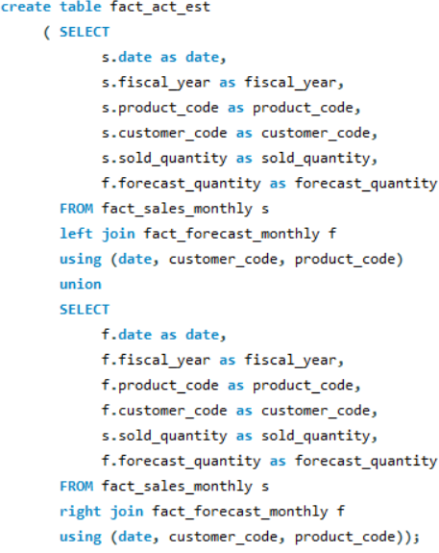

Output

25.To Replace null values with 0

Output

